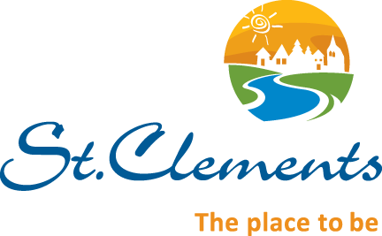

Employment Opportunity

Heritage – East Beaches Heritage Wing Interpreter

Reporting to the Recreation Manager, the RM of St. Clements is seeking candidates for the position of Heritage Wing Interpreter. The Heritage Wing is an exhibit designed to interpret the heritage and culture of the region located on the east shore of the south basin of Lake Winnipeg. Designed by a professional designer and managed by a group of local volunteers, the facility uses many interactive and static displays to relate stories of the region and provide visitors with a unique heritage experience. The ideal candidate will have a positive attitude with an interest in heritage and the East Beaches region.

Essential Job Functions
- Have an understanding of all exhibits and history of the region.
- Interpret the exhibits to visitors.
- Interact with visitors to enhance their experience of the Heritage Wing.
- Ensure all exhibits function properly and are in working order.
- Maintain cleanliness of the Heritage Wing.
- Provide visitors with other information about the community and tourism opportunities in the area.
- Provide periodic summaries of attendance and other events and concerns.
- Perform other tasks as assigned by the RM Heritage Committee.
- Support social media sites associated with the facility.

Requirements
- Has an interest in the heritage of the East Beaches region and knowledge of the community.
- Ability to work independently under minimal direct supervision.
- Strong verbal communication skills and experience dealing with public.
- Applicants enrolled in or have completed post-secondary education in fields such as history, arts, or communications would be an asset.

This is a part-time, seasonal position.

Applications will be reviewed as early as March 25, 2024, however the posting will remain opened until a suitable candidate is located.
Qualified candidates are invited to submit a cover letter and resume to:

ATTN: Brenden Collins, Recreation Manager
Rural Municipality of St. Clements
1043 Kittson Road
Box 2, GRP 35, RR1
East Selkirk, Manitoba
R0E 0M0
Email: recreation@rmofstclements.com

We thank all applicants for their interest in this position but only those selected for an interview will be contacted.

