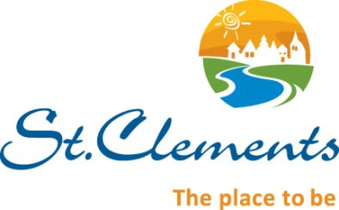
RURAL MUNICIPALITY OF
ST. CLEMENTS

EMPLOYMENT OPPORTUNITY

April 8, 2024

The Rural Municipality of St. Clements invites applications for a Summer Green Team (approximately early May to late October).

Applications with detailed resume, clearly stating the position (s) applied for, will be received at the Municipal Offices, East Selkirk Manitoba or via email to pwadmin@rmofstclements.com.

Summer Green Team:
The successful candidate must have the following qualifications:
- Between the ages of 15 and 29
- Minimum valid Class 5 Driver’s License
- Clean Driving Abstract

Work includes:
- Playground and park grounds maintenance
- Mowing and trimming maintain other green spaces
- Weed control (no chemicals)
- Misc painting of public facilities
- Misc refuse and recycling clean up, litter picking
- Graffiti removal
- Sidewalk and trail enhancements
- Maintenance Work in park enhancements
- Other duties as assigned

Rate of Pay: $18.30/hr

We thank all candidates for their interest, however, only those candidates selected for interviews will be contacted.

Kevin Grabowski, C.E.T.
Director of Public Works
R.M. of St. Clements
East Selkirk, Manitoba, R0E 0M0

